

Year 8 Science

**Biology 2 Test: Systems**

**SECTION 1: MULTIPLE CHOICE** (1 mark each)

Circle your answer on the multiple choice answer sheet.

1. What makes up most of the volume of blood?
   1. red blood cells
   2. white blood cells
   3. platelets
   4. plasma
2. The trachea belongs to which system?
   1. respiratory
   2. reproductive
   3. excretory
   4. circulatory
3. Oxygen is mainly carried in the blood in the
   1. Red blood cells
   2. Platelets.
   3. White blood cells.
   4. Alveoli
4. A component of the heart that prevents the reverse flow of blood is called the:
   1. vena cava
   2. right atrium.
   3. atrioventricular valve.
   4. aorta.
5. Which statement is false?
   1. The pistil (or female part) of the flower contains the stigma, style and ovary.
   2. The ovary produces ovules (or egg cells).
   3. When fertilised, the ovules will become seeds and the ovary will become fruit.
   4. The ovary produces nectar and pollen
6. Which of the following is the smallest type of blood vessel?
7. Capillaries
8. Arteries
9. Arterioles
10. Veins.
11. The plant equivalent of sperm is

a) anthers

b) ovules

c) stigma

d) pollen

1. Which statement is true?
   1. The majority of gas exchange in humans occurs in the mouth.
   2. The majority of gas exchange in humans occurs in the alveoli.
   3. The majority of gas exchange in humans occurs in the rib cage.
   4. The majority of gas exchange in humans occurs in the trachea
2. Which statement about the phloem is correct
3. It carries sugars from the roots to the leaves
4. It carries ions from the leaves to the roots
5. It carries water from the roots to the leaves
6. It carries sugars from leaves to all other plant parts.
7. What is the loss of water vapour from the leaves called?
8. Evaporation
9. Osmosis
10. Transpiration
11. Diffusion

 **2020 Biology 2**

**SYSTEMS**

**Multiple Choice Answer Sheet**

**Name: ___________________ Year: 8**

**Multiple Choice – 10 questions.**

Circle your choice. If you change your mind, scrub your choice out and circle the one you want. If it is messy, clearly write your choice next to question.

1. A B C D

2. A B C D

3. A B C D

4. A B C D

5. A B C D

6. A B C D

7. A B C D

8. A B C D

9. A B C D

10. A B C D

Correct answers: ______ / 10 questions

**SECTION 2: WRITTEN 25 MARKS**

**Write your answers in the spaces on the answer sheet provided.**

1. a. Label the following diagram of the heart (7 marks)

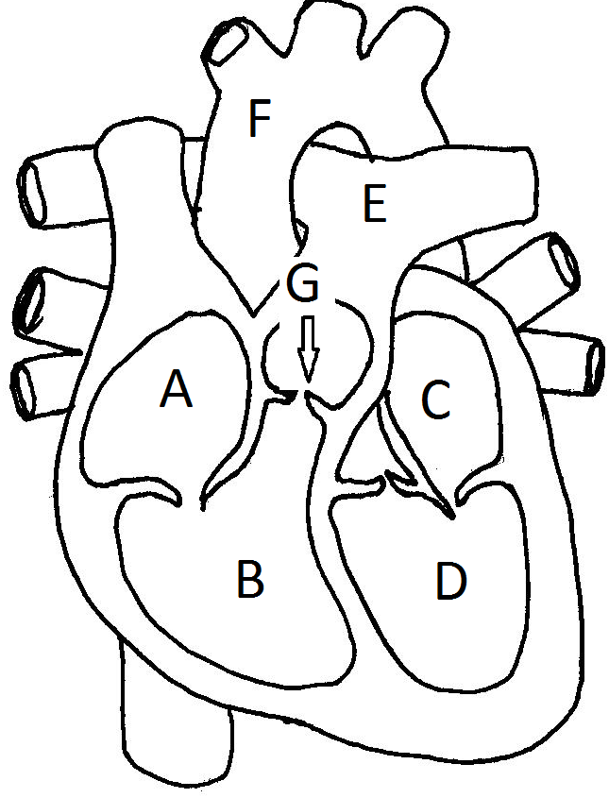

A - __________________

B - __________________

C - __________________

D - __________________

E - __________________

F - __________________

G - __________________

b. Veins usually carry deoxygenated blood. Explain why the pulmonary vein is an exception. (2 marks)

__________________________________________________________________________________________________________________________________________________________________________________________________________________________________________________________________________________________________________________________________________

2. a. Label the following diagram of the respiratory system (3 marks)

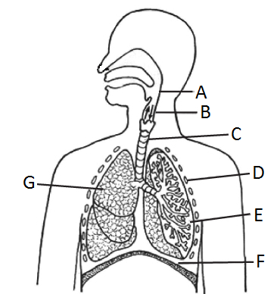

A - ______________________

C - ______________________

D - ______________________

E - ______________________

F - ______________________

G - ______________________

b. What is the shape and purpose of the cartilage found in the trachea?

(2 marks)

___________________________________________________________________________________________________________________________________________________________________________________________________

3. a. Label the following diagram (3 marks)

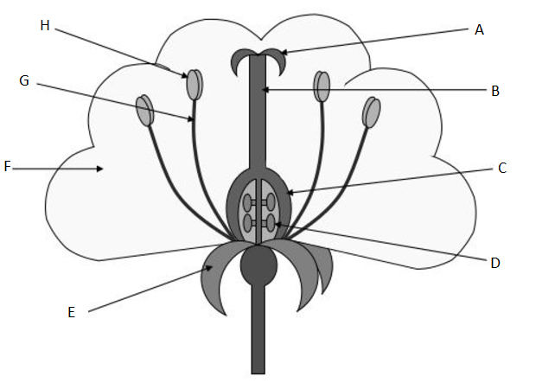

A - __________________

B - __________________

C - __________________

D - __________________

G - __________________

H - __________________

b. Not all plants depend on flowers to reproduce. Name a method of reproduction a plant may use to reproduce that does not involve a flower. Use an example explain the method. (3 marks)

_____________________________________________________________________________________________________________________________________________________________________________________________________________________________________________________________________________________________________________________________________

4. Complete the following table. (5 marks)

|  |  |  |
| --- | --- | --- |
|  | **Asexual** | **Sexual** |
| **Definition** | A form of reproduction where one parent produces the offspring |  |
| **Advantage** |  |  |
| **Disadvantage** |  |  |

**END OF TEST (Total 35 MARKS)**